Curriculum Vitae
Personal Data:
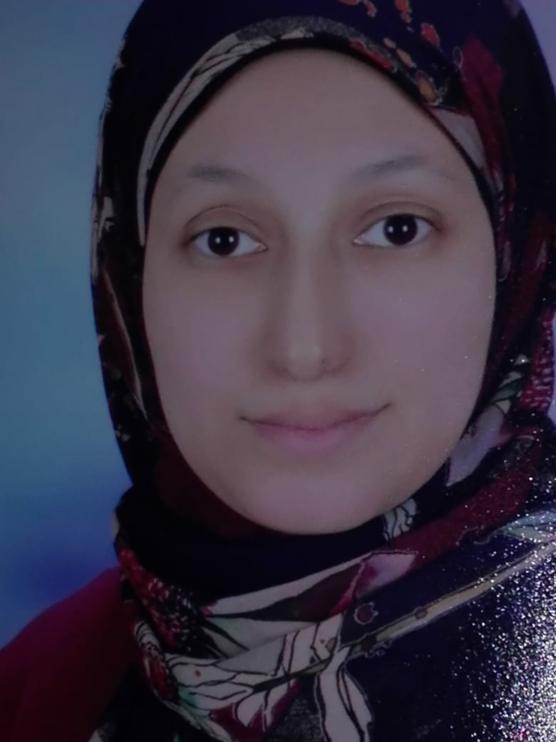
Name: Hager Mohamed Hemdan
Sex:femal
Date of birth: 25-8-1989
Marital status: maried
Telephone numbers:
Home:
Mobile: 01020114680

E mail : hagaraziz92@yahoo.com
Hager.hemdan@med.sohag.edu.eg

Address of correspondance:
Sohag, 1 naser street

Qualifications

(M.B. B. Ch.)Faculty of Medicine – Sohag University

Academic Experience: master degree

- Publications
The histological effects of zinc oxide nanoparticles on the kidney of adult male rabbits

